- Copyright for test papers and marking guides remains with West Australian Test Papers.
- The papers may only be reproduced within the purchasing school according to the advertised conditions of sale.
- Test papers must be withdrawn after use and stored securely in the school until Friday 29th November.

Insert School Logo
CHEMISTRY

UNITS 1 & 2

2019

Name: _________________________________________________________________________________________

Teacher: ________________________________________________________________________________________

TIME ALLOWED FOR THIS PAPER

Reading time before commencing work: ten minutes
Working time for the paper: three hours

MATERIALS REQUIRED/RECOMMENDED FOR THIS PAPER

To be provided by the supervisor:
This Question/Answer Booklet
Multiple-choice Answer Sheet
Chemistry Data Book

To be provided by the candidate:
Standard items: pens (blue/black preferred), pencils (including coloured), sharpener,
eraser, correction tape/fluid, ruler, highlighters

Special items: up to three non-programmable calculators approved for use in the WACE examinations

IMPORTANT NOTE TO CANDIDATES
No other items may be taken into the examination room. It is your responsibility to ensure that you do not have any unauthorised notes or other items of a non-personal nature in the examination room. If you have any unauthorised material with you, hand it to the supervisor before reading any further.

Structure of this paper

Section | Number of questions available | Number of questions to be answered | Suggested working time  (minutes) | Marks available | Percentage of exam
Section One:  Multiple-choice | 25 | 25 | 50 | /50 | /25
Section Two:  Short answer | 8 | 8 | 60 | /70 | /35
Section Three:  Extended answer | 5 | 5 | 70 | /80 | /40
 |  |  |  |  | /100

Instructions to candidates

1. Answer the questions according to the following instructions.

Section One: Answer all questions on the separate Multiple-choice Answer Sheet provided. For each question shade the box to indicate your answer. Use only a blue or black pen to shade the boxes. If you make a mistake, place a cross through that square then shade your new answer. Do not erase or use correction fluid/tape. Marks will not be deducted for incorrect answers. No marks will be given if more than one answer is completed for any question.

Sections Two and Three: Write your answers in this Question/Answer Booklet.

2. When calculating numerical answers, show your working or reasoning clearly. Express numerical answers to the appropriate number of significant figures and include appropriate units where applicable.

3. You must be careful to confine your responses to the specific questions asked and to follow any instructions that are specific to a particular question.

4. Spare pages are included at the end of this booklet. They can be used for planning your responses and/or as additional space if required to continue an answer.
  - Planning: If you use the spare pages for planning, indicate this clearly at the top of the page.
  - Continuing an answer: If you need to use the space to continue an answer, indicate in the original answer space where the answer is continued, i.e. give the page number. Fill in the number of the question(s) that you are continuing to answer at the top of the page.

5. The Chemistry Data Book is not handed in with your Question/Answer Booklet.

Section One: Multiple-choice 25% (50 marks)

This section has 25 questions. Answer all questions on the separate Multiple-choice Answer Sheet provided. For each question, shade the box to indicate your answer. Use only a blue or black pen to shade the boxes. If you make a mistake, place a cross through that square then shade your new answer. Do not erase or use correction fluid/tape. Marks will not be deducted for incorrect answers. No marks will be given if more than one answer is completed for any question.

Suggested working time: 50 minutes.

Questions 1 and 2 relate to the information given in the following table.

 | Number of protons | Number of neutrons | Number of electrons
W | 7 | 8
X |  | 12 | 10
Y |  | 12 | 11
Z | 3
V | 12 | 13 | 12

1. Considering the incomplete information provided, which statement can be made with certainty?

- W is a nitrogen ion
- X is a neon atom
- Y is a magnesium isotope
- Z is the element lithium

2. Examine the subatomic particle arrangement of V. The species most likely to be an isotope of V is

- W
- X
- Y
- Z

3. If 1.0 mol L⁻¹ hydrochloric acid was poured into a test tube containing small pieces of cobalt metal, which of the following would not be observed?

- The silver metal would dissolve.
- A colourless, odourless gas would be produced.
- The solution would become blue in colour.
- The test tube would feel warm.
4. Thin layer chromatography (TLC) can be used to analyse the various natural sweeteners found in food and drink. The following table gives some data regarding the R_{f} values (see formula below) of different natural sweeteners.

R_{f} = distance travelled by component
distance travelled by solvent

Sweetener | R_{f}
Glucose | 0.60
Fructose | 0.60
Sucrose | 0.55
Maltose | 0.50
Maltotriose | 0.41
Maltotetraose | 0.30
Maltopentaose | 0.22
Maltohexaose | 0.16

A small amount of food was analysed by TLC under the same conditions used to produce the data above. This plate is shown below.

solvent front = 11.2 cm
6.72 cm
6.16 cm
2.46 cm

Which sweetener has the highest certainty of being present in this food sample?

- Sucrose
- Maltose
- Glucose
- Fructose

5. Substance X has the following properties;

  - Low boiling point
  - Dissolves in water
  - Does not conduct electricity when in aqueous solution

Substance X is most likely

- ionic.
- polar covalent molecular.
- non-polar covalent molecular.
- covalent network.

6. Which gives the correct percentage abundance of each isotope of rubidium, if the known relative atomic mass of rubidium is 85.46?

Isotope 1 A_{r} = 84.9 Isotope 2 A_{r} = 86.9
- 79.3% 20.7%
- 72.2% 27.8%
- 66.4% 33.6%
- 59.7% 40.3%

Questions 7 and 8 refer to the reaction below.

The following chemical equation can be used to represent the combustion of natural gas or biogas, since both contain methane.

CH₄(g) + 2 O₂(g) → CO₂(g) + 2 H₂O(g) + 882 kJ

7. The difference when the methane in biogas is combusted is that

- the methane is made from biological material.
- the methane is more pure.
- less carbon dioxide is produced during combustion.
- more energy is produced during combustion.

8. According to the Laws of Conservation of Energy and Mass, which statement is not correct?

- The mass of carbon in the reactants is equal to the mass of carbon in the products.
- The number of atoms of hydrogen in the reactants is equal to the number of atoms of hydrogen in the products.
- The moles of oxygen in the reactants is equal to the moles of oxygen in the products.
- The enthalpy of the reactants is equal to the enthalpy of the products.
Questions 9 and 10 relate to the following four organic compounds.

A  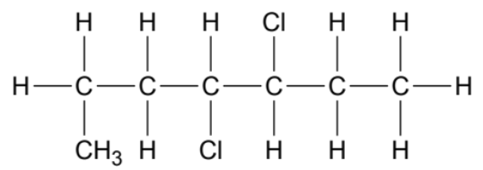 | B  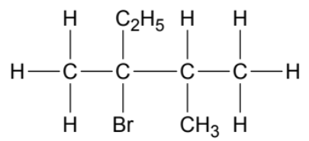
C  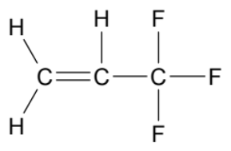 | D  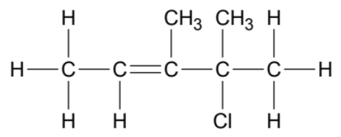

9. The correct IUPAC name for

- A is 3,4-dichloro-1-methylhexane.
- B is 3-bromo-2,3-dimethylpentane.
- C is 3,3,3-trifluorobut-1-ene.
- D is 2-chloro-2,3-dimethylpent-3-ene.

10. If a sample of C was mixed with water in the presence of an appropriate catalyst, the most likely product(s) would be

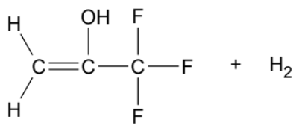

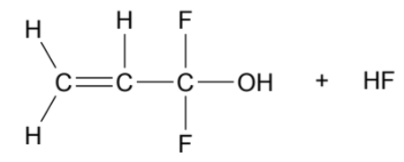

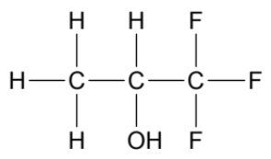

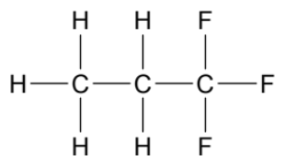

11. Consider the following information regarding the boiling point of four of the hydrogenhalides.

 | HF | HCl | HBr | HI
Boiling point (°C) | 19.5 | -85.1 | -66.8 | -35.4

Which of these statements are correct?

- HF is the most polar.
- HF has the strongest hydrogen bonds.
- HF has the strongest dipole-dipole forces.
- HF has the strongest dispersion forces.
- HF has the strongest intermolecular forces.

- (i), (ii) and (iii) only
- (i), (ii) and (v) only
- (ii), (iii) and (iv) only
- (i), (ii), (iii) and (v) only

Questions 12 and 13 refer to the three indicators listed below.

The diagram below provides information about three different indicators and the colours they display at various pH levels.

0 1 2 3 4 5 6 7 8 9 10 11 12 13 14

pH

methyl red | red |  | yellow
phenol red | yellow |  |  | red
thymol blue | red | yellow |  |  | blue

12. An unknown substance was tested with all three indicators and turned yellow in each case. Therefore

- the substance is acidic.
- the substance is basic.
- the substance is neutral.
- not enough information is available to make a conclusion.

13. Two substances were tested with thymol blue. One turned red, while the other turned blue. Which statement is not correct regarding the red solution?

- The red solution is more acidic.
- The red solution has a lower hydrogen ion concentration.
- The red solution has a lower hydroxide ion concentration.
- The red solution has a lower pH.

Questions 14 and 15 relate to the data provided below.

Gas chromatography (GC) can be used to accurately determine a person’s blood alcohol concentration. The following table and chromatogram provide select information about five different alcohols that commonly undergo analysis.

 | Name of alcohol | Structural diagram | Boiling point (°C)
1 | methanol | 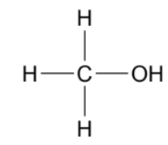 | 64.7
2 | propanone | 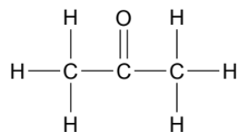 | 56.0
3 | ethanol | 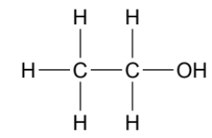 | 78.4
4 | 2-propanol | 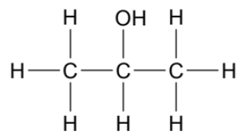 | 82.5
5 | 2-methyl-2-propanol | 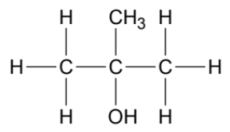 | 82.0

14. Which statement regarding the five alcohols is not correct?

- Propanone would have the highest vapour pressure.
- The vapour pressure of ethanol would be lower than the vapour pressure of methanol.
- 2-propanol has the strongest intermolecular forces.
- Vapour pressure increases with increasing strength of intermolecular forces.

15. The data from the chromatogram indicates that

- the components elute in order of boiling point.
- the components elute in order of molecular weight.
- the alcohol with greatest concentration is ethanol.
- the carrier gas would have the longest elution time.

16. Which of the following aqueous solutions would be the best conductor of electricity?

- 0.1 mol L⁻¹ Al(NO₃)₃(aq).
- 0.2 mol L⁻¹ Cr₂(SO₄)₃(aq).
- 0.3 mol L⁻¹ KCH₃COO(aq).
- 0.4 mol L⁻¹ LiCl(aq).

17. Consider the partially completed table below and choose the correct alternative.

Name | Formula
A | Fe₂(SO₄)₃
dinitrogen tetrahydride | B
C | H₂SO₃
lithium hydrogenphosphate | D

- A is iron(II) sulfate.
- B is N₂O₄.
- C is sulfuric acid.
- D is Li₂HPO₄.

18. Which list correctly shows the electron configuration of the following species?

¹⁹F K⁺ N³⁻
- 2, 7 2, 8, 8 2, 8
- 2, 8, 8, 1 2, 8, 9 2, 8, 4
- 2, 7 2, 8, 8 2, 5
- 2, 8, 9 2, 8, 8, 1 2, 8

19. Choose the correct statement regarding the behaviour of electrons during bonding.
- In metallic bonding, electrons are transferred.
- In ionic bonding, electrons are shared.
- In covalent molecular bonding, electrons are delocalised.
- In covalent network bonding, electrons are localised.

20. Consider the flow chart shown below.

salt water
sodium chloride
sodium metal
chlorine gas
evaporation
electrolysis

Which of the following is/are pure substances?

- Salt water
- Sodium chloride
- Sodium metal
- Chlorine gas

(a) (ii) only
(b) (iii) and (iv) only
(c) (ii), (iii) and (iv) only
(d) all of (i), (ii), (iii) and (iv)

21. All the allotropes of carbon

- are nanomaterials.
- are hard and brittle.
- conduct electricity.
- are composed of carbon atoms only.

22. A beaker contained 0.1 mol L⁻¹ sodium chloride (NaCl) solution. Whilst the conductivity of this solution was being measured, an equal volume of 0.1 mol L⁻¹ silver nitrate (AgNO₃) solution was poured slowly into the sodium chloride. As the two solutions were being mixed, the measured current would

(a) increase.
(b) remain constant.
(c) decrease.
(d) become zero.

Questions, 23, 24 and 25 relate to the reaction below.

When ammonia and hydrogen chloride gases are mixed, the formation of a ‘white smoke’ can be observed. This reaction can be represented by the following chemical equation.

NH₃(g) + HCl(g) → NH₄Cl(s)

The rate of this reaction is very fast. The NH₄Cl(s) can be seen forming quickly when the reaction is carried out at room temperature and atmospheric pressure conditions.

23. This suggests that the activation energy is likely to be

- zero.
- small.
- large.
- extremely large.

In order to investigate the rate of this reaction, the total mass of NH₄Cl(s) produced was measured at various time points. The solid line on the graph below illustrates the data collected.

C
B
A

24. Which statement regarding the measured rate of reaction (solid line) is not correct?

(a) From 0-5 seconds the average reaction rate is 0.12 g sec⁻¹.
(b) From 5-10 seconds the average reaction rate is 0.07 g sec⁻¹.
(c) After 10 seconds the reaction rate is zero.
(d) The reaction rate is fastest immediately after Time = 0.

25. If the same number of moles of reactants were mixed at higher pressure, which line on the graph above most accurately predicts the expected results? (Assume all other reaction conditions remain unchanged.)
- A
- B
- C
- It would be the same as the original solid line.

End of Section One
Section Two: Short answer 35% (70 marks)

This section has 8 questions. Answer all questions. Write your answers in the spaces provided.

When calculating numerical answers, show your working or reasoning clearly. Express numerical answers to the appropriate number of significant figures and include appropriate units where applicable.

Spare pages are included at the end of this booklet. They can be used for planning your responses and/or as additional space if required to continue an answer.
- Planning: If you use the spare pages for planning, indicate this clearly at the top of the page.
- Continuing an answer: If you need to use the space to continue an answer, indicate in the original answer space where the answer is continued, i.e. give the page number. Fill in the number of the question(s) that you are continuing to answer at the top of the page.

Suggested working time: 60 minutes.

Question 26 (13 marks)

Consider the solubility data provided in the table below.

Substance | Solubility in water at 25 °C
KCl | 254 g L⁻¹
SO₂ | 94.0 g L⁻¹
I₂ | 0.290 g L⁻¹

(a) Explain, in terms of intermolecular forces, the differing solubilities of SO₂ and I₂ in water. (4 marks)

________________________________________________________________________

________________________________________________________________________

________________________________________________________________________

________________________________________________________________________

________________________________________________________________________

________________________________________________________________________

________________________________________________________________________

________________________________________________________________________

________________________________________________________________________

________________________________________________________________________

(b) Draw a labelled diagram showing the arrangement of solute and solvent species, and the attractive forces that exist, when KCl has been dissolved in water. (3 marks)

(c) Using the data in the table, describe how you would produce a saturated solution of KCl, if you were given a 31.75 g sample of KCl(s). (2 marks)

________________________________________________________________________

________________________________________________________________________

________________________________________________________________________

________________________________________________________________________

(d) Calculate the concentration in parts per million, of a saturated solution of KCl at 25 °C. The density of the solution is 1.178 g mL⁻¹. (4 marks)

Question 27 (7 marks)

The graph below displays data on the first ionisation energy of eight (8) successive elements on the periodic table (labelled as A-H).

(a) Define ‘first ionisation energy’. (2 marks)

________________________________________________________________________

________________________________________________________________________

________________________________________________________________________

________________________________________________________________________

(b) Which element (A-H) (5 marks)

- has the smallest atomic radius? _________________________

- has the highest electronegativity? _________________________

- is most likely to form covalent network bonds? _________________________

- is an alkaline earth metal? _________________________

- is most likely to form an anion with 2- charge? _________________________

Question 28 (8 marks)

One of the functions of a catalytic converter in a car, is to convert poisonous carbon monoxide gas into non-toxic carbon dioxide. This reaction can be catalysed by single platinum atoms which are attached to a copper(II) oxide support. The activation energy in the presence of these platinum atoms is 138 kJ. The chemical equation for this reaction is given below.

Pt
2 CO(g) + O₂(g) 2 CO₂(g) + 566 kJ

(a) Draw, to scale, an energy profile diagram for the catalysed reaction. Label the activation energy and the heat of reaction. (4 marks)

Progress of reaction
Potential energy (kJ)

(b) State how the value of the activation energy and the heat of reaction would be altered (higher, lower, no change) in the uncatalysed reaction. (2 marks)

Value
(higher / lower / no change)
Activation energy
Heat of reaction

Single platinum atoms have a diameter of 0.278 nm.

(c) Define a ‘nanomaterial’, and state whether this platinum catalyst qualifies as a nanomaterial. (2 marks)

________________________________________________________________________

________________________________________________________________________

________________________________________________________________________

________________________________________________________________________

Question 29 (9 marks)
Volume
Pressure

The following graph illustrates Boyle’s law, which shows the relationship between the pressure and volume of an ideal gas at constant temperature.

As suggested by the shape of the graph, no matter how high the pressure is increased, the volume of the gas will never become zero.

(a) Explain why this is so, referring to the difference between ‘ideal’ and ‘real’ gases in your answer. (3 marks)

________________________________________________________________________

________________________________________________________________________

________________________________________________________________________

________________________________________________________________________

________________________________________________________________________

________________________________________________________________________

________________________________________________________________________

________________________________________________________________________

A sample of methane gas was stored in a chamber at 34 °C and 92 kPa.

(b) What changes would need to be made to the storage temperature and volume to achieve STP conditions? (circle your answer for each) (2 marks)

Temperature Volume

increase / decrease increase / decrease

The final volume of methane gas, once corrected to STP, was 673.5 mL.

(c) Calculate the number of molecules of methane gas present. State your answer to the correct number of significant figures. (3 marks)

(d) Calculate the number of hydrogen atoms present in this gas sample. (1 mark)

Question 30 (8 marks)

The following question refers to four (4) different substances, each displaying a different type of bonding. One substance is metallic, one is ionic, one is covalent molecular and one is covalent network. You may assume each of the substances show the typical characteristic properties of the four bonding types.

(a) Complete the following dichotomous key, by writing the name of one type of bonding (metallic, ionic, covalent molecular, covalent network) in each of the boxes labelled W, X, Y and Z. (4 marks)

brittle
4 types of bonding
solid at room temperature
not solid at room temperature
not brittle
soluble in water
not soluble in water
Y
Z
W
X

(b) Justify the choice of bonding you made for W. (2 marks)

________________________________________________________________________

________________________________________________________________________

________________________________________________________________________

________________________________________________________________________

________________________________________________________________________

________________________________________________________________________

(c) Justify the choice of bonding you made for X. (2 marks)

________________________________________________________________________

________________________________________________________________________

________________________________________________________________________

________________________________________________________________________

________________________________________________________________________

________________________________________________________________________

Question 31 (9 marks)

Calcium dihydrogenphosphate, Ca(H₂PO₄)₂, and ammonium hydrogenphosphate, (NH₄)₂HPO₄, are both compounds that are commonly found in fertilisers.

(a) Determine the percentage by mass of phosphorus that could be released into the soil by each compound. (4 marks)

(b) Describe how these two white salts could be distinguished using a flame test. Your answer should include an explanation of how an emission spectrum is produced in a flame test. (5 marks)

________________________________________________________________________

________________________________________________________________________

________________________________________________________________________

________________________________________________________________________

________________________________________________________________________

________________________________________________________________________

________________________________________________________________________

________________________________________________________________________

________________________________________________________________________

________________________________________________________________________

Question 32 (7 marks)

Cow’s milk is a very nutritious substance. However, it tends to sour quickly and have a short shelf life. This is due to the presence of bacteria in milk called lactobacillus. These bacteria convert the lactose present in milk into lactic acid. This chemical reaction increases the acidity of the milk, causing it to taste sour and separate into solid curds and liquid whey.

One process used to increase the shelf life of milk is pasteurisation. The process of pasteurisation kills many of the bacteria that convert the lactose to lactic acid.

(a) Explain, in terms of the collision theory, how the pasteurising process increases the shelf life of milk. (3 marks)

________________________________________________________________________

________________________________________________________________________

________________________________________________________________________

________________________________________________________________________

________________________________________________________________________

________________________________________________________________________

Since pasteurisation does not kill all of the bacteria, milk is also cooled and refrigerated at a temperature of around 4 °C to increase its shelf life.

(b) On the curve below, sketch the effect of refrigeration on the distribution of molecular energies in milk. (1 mark)
Kinetic energy
Number of particles
milk collected at 37 °C

(c) Explain, in terms of the collision theory, how the refrigeration process increases the shelf life of milk. (3 marks)

________________________________________________________________________

________________________________________________________________________

________________________________________________________________________

________________________________________________________________________

________________________________________________________________________

________________________________________________________________________
Question 33 (9 marks)

Use the eight (8) substances below to answer the following questions. Each substance may only be used once.

PCl₃ SO₃ N₂ CS₂

SiH₄ CH₂Cl₂ Zn(NO₃)₂ H₂S

(a) Draw the structural formula for a substance containing no polar bonds. Represent all valence shell electron pairs either as : or –. (1 mark)

(b) Draw the structural formula for an ionic substance. Represent all valence shell electron pairs either as : or –. (2 marks)

(c) Draw the structural formula for a substance matching each molecular shape. Represent all valence shell electron pairs either as : or –. (2 marks)

Triangular planar | V-shaped / Bent
(d) Draw the structural formulas for two substances that are non-polar. Represent all valence shell electron pairs either as : or –. (2 marks)

(e) Draw a diagram illustrating dipole-dipole forces between molecules of the same substance. (2 marks)

End of Section Two
Section Three: Extended answer 40% (80 marks)

This section contains five (5) questions. You must answer all questions. Write your answers in the spaces provided below.

Where questions require an explanation and/or description, marks are awarded for the relevant chemical content and also for coherence and clarity of expression. Lists or dot points are unlikely to gain full marks.

Final answers to calculations should be expressed to the appropriate number of significant figures.

Spare pages are included at the end of this booklet. They can be used for planning your responses and/or as additional space if required to continue an answer.
- Planning: If you use the spare pages for planning, indicate this clearly at the top of the page.
- Continuing an answer: If you need to use the space to continue an answer, indicate in the original answer space where the answer is continued, i.e. give the page number. Fill in the number of the question(s) that you are continuing to answer at the top of the page.

Suggested working time: 70 minutes.

Question 34 (16 marks)

The colourless liquid 1,1,1-trichloroethane was once widely manufactured and used as an aerosol propellant, a cleaning agent for circuit boards and an organic solvent for inks, paints and adhesives. However, it has been banned since 1996 because it was found to be one of the group of compounds contributing to the formation of the ‘hole in the ozone layer’.

Industrially 1,1,1-trichloroethane was produced in two steps. Step 1 involves the reaction of chloroethene with hydrogen chloride to produce 1,1-dichloroethane. This reaction is catalysed by aluminium chloride or iron(III) chloride.

In Step 2, the 1,1-dichloroethane reacts with chlorine in the presence of UV radiation to produce 1,1,1-trichloroethane. This step also forms hydrogen chloride, which is recycled for use in Step 1.

The chemical equations for the production of 1,1,1-trichloroethane are given below.

Step 1

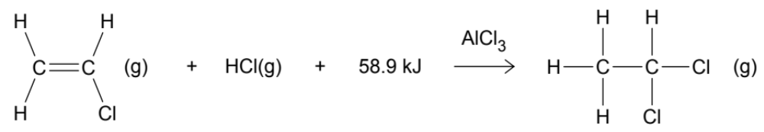

Step 2

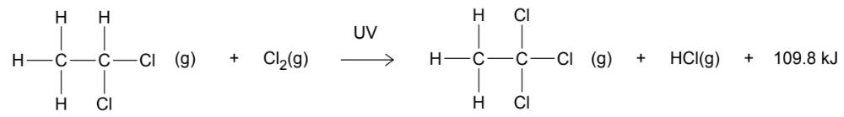
(a) Name the type of reactions occurring in Step 1 and Step 2. Briefly explain the difference between these reaction types. (4 marks)

Step 1 reaction: ___________________________________________________________

Step 2 reaction: ___________________________________________________________

________________________________________________________________________

________________________________________________________________________

________________________________________________________________________

________________________________________________________________________

________________________________________________________________________

________________________________________________________________________

________________________________________________________________________

The reaction in Step 2 also produces a small quantity of a second organic product. This unwanted product is separated from the 1,1,1-trichloroethane by distillation.

(b) Draw a structural diagram (i.e. showing all bonds) and give the IUPAC name for this unwanted organic product. (2 marks)

Structural diagram | IUPAC name

(c) Describe how the process of distillation can be used to separate a mixture. (3 marks)

________________________________________________________________________

________________________________________________________________________

________________________________________________________________________

________________________________________________________________________

________________________________________________________________________

________________________________________________________________________

If 976 g of 1,1,1-trichloroethane is produced;

(d) Calculate the volume of chloroethene, stored at STP, that would be required for this process. (You may ignore the formation of unwanted organic products and assume both reactions are 100% efficient.) (3 marks)

(e) Classify the overall two-step production process as endothermic or exothermic. Justify your answer. (2 marks)

________________________________________________________________________

________________________________________________________________________

________________________________________________________________________

________________________________________________________________________

(f) Calculate the quantity of energy released, or absorbed, if this mass of 1,1,1-trichloroethane is produced. (2 marks)

Question 35 (22 marks)

Earth is sometimes referred to as a ‘Goldilocks’ planet. This is because the average global surface temperature of 15 °C is not too hot, nor too cold, but “just right” for water to exist as a liquid.

The table below provides data regarding two substances of similar molecular mass; water and methane.

 | M | Melting point (°C) | Boiling point (°C)
Water (H₂O) | 18.016 | 0 | 100
Methane (CH₄) | 16.042 | -182 | -162

(a) Explain why the dispersion forces in water and methane are of similar strength. (2 marks)

________________________________________________________________________

________________________________________________________________________

________________________________________________________________________

________________________________________________________________________

________________________________________________________________________

________________________________________________________________________

(b) Explain why the boiling point of water and methane differ so greatly. (4 marks)

________________________________________________________________________

________________________________________________________________________

________________________________________________________________________

________________________________________________________________________

________________________________________________________________________

________________________________________________________________________

________________________________________________________________________

________________________________________________________________________

________________________________________________________________________

________________________________________________________________________

An interesting and rare property of water is that it is less dense in the solid state than in the liquid state.

(c) Explain why ice is less dense than water. (2 marks)

________________________________________________________________________

________________________________________________________________________

________________________________________________________________________

________________________________________________________________________

________________________________________________________________________

Potable (drinking) water is subject to regular analysis to monitor its quality. One of the factors assessed in potable water, is the presence of heavy metal contaminants such as arsenic, cadmium, chromium, lead and mercury.

Cadmium can be found in water in the form of Cd²⁺(aq) ions. It is a toxic substance that can cause damage to the kidneys, liver, lungs and central nervous system. The maximum amount of Cd²⁺(aq) allowed in potable water, as set by the U.S. Environmental Protection Agency, is 0.005 mg L⁻¹.

Analysis for Cd²⁺(aq) is routinely performed by atomic absorption spectroscopy (AAS), due to its ability to detect extremely low concentrations of metals. The AAS calibration curve for Cd²⁺(aq) is shown below.

Samples of water were taken from three different locations around a mine site and analysed by AAS for the presence of Cd²⁺(aq). The results of the analysis are provided in the table.

Sample | Absorbance
X | 0.33
Y | 0.40
Z | 0.21

(d) Do any of the water samples (X, Y, Z) contain Cd²⁺(aq) at a level too high for human consumption? Justify your answer using the graph provided. (3 marks)

________________________________________________________________________

________________________________________________________________________

________________________________________________________________________

________________________________________________________________________

________________________________________________________________________

________________________________________________________________________

The Cd²⁺(aq) from a highly contaminated sample of water was to be removed by precipitation. The analysis by AAS determined the concentration of Cd²⁺(aq) in the water to be 0.0723 mg L⁻¹.

(e) Calculate the concentration of Cd²⁺(aq) in moles per litre (mol L⁻¹). (2 marks)

A water tank, holding 35 kL of this contaminated water (containing 0.0723 mg L⁻¹ of Cd²⁺), was treated with excess sodium sulfide to precipitate out all the cadmium ions. A 2.0 L sample of 0.0125 mol L⁻¹ sodium sulfide was added to the tank. The water in the tank was mixed and left until the reaction was complete.

The chemical equation for the reaction that took place is given below.

Cd²⁺(aq) + Na₂S(aq) → CdS(s) + 2 Na⁺(aq)

(f) Calculate the mass of CdS(s) that would precipitate in the tank. (4 marks)

(g) Calculate the final concentration of Na⁺(aq) and S²⁻(aq) in the tank. (5 marks)

This page has been left blank intentionally
Question 36 (11 marks)

High performance liquid chromatography (HPLC) can be used to test for the presence of different amino acids in food. This is generally done using ‘reverse-phase HPLC’ which uses a non-polar stationary phase in combination with a polar mobile phase.

(a) Explain how reverse-phase HPLC is able to separate the components of a substance. Your answer should refer to the role of both the stationary and mobile phases and the effect of component polarity on retention / elution time. (5 marks)

________________________________________________________________________

________________________________________________________________________

________________________________________________________________________

________________________________________________________________________

________________________________________________________________________

________________________________________________________________________

________________________________________________________________________

________________________________________________________________________

________________________________________________________________________

________________________________________________________________________

The chromatogram below was obtained from a reverse-phase HPLC analysis. This particular analysis identifies the presence of 11 different amino acids.

Two peaks on the chromatogram have been labelled X and Y. These correspond to the amino acids serine and leucine. Structural diagrams of serine and leucine are shown below.

Serine Leucine

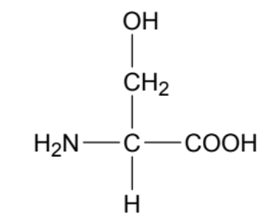
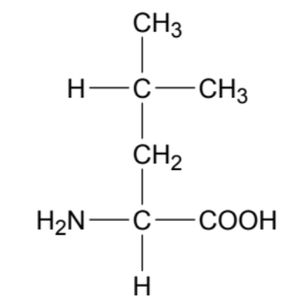

(b) On the diagrams above, circle the sections where the amino acid molecules differ structurally from one another. (1 mark)

(c) Considering the circled sections, predict which amino acid corresponds to X and Y on the chromatogram. Briefly justify your answer. (3 marks)

X is: ____________________________________________________________________

Y is: ____________________________________________________________________

________________________________________________________________________

________________________________________________________________________

________________________________________________________________________

________________________________________________________________________

________________________________________________________________________

________________________________________________________________________

People who have phenylketonuria (PKU) are born with a genetic condition where they are unable to metabolise the amino acid phenylalanine.

When people with PKU consume foods containing phenylalanine, levels of this amino acid can build up in their blood. Without treatment, the disorder can cause intellectual disability and seizures.

All babies born in Australia are screened for PKU at birth, and a strict diet low in phenylalanine is introduced. In this way, the effects of the disorder can be avoided.

Three different foods - Weetbix, celery and fish - were analysed for their amino acid composition. The reverse-phase HPLC analysis was performed under the same conditions as the chromatogram on page 32.

The results of the analyses are shown in the chromatograms below.

(d) If you were making a recommendation to someone who had PKU about which of these three foods to consume, select which food would be; (2 marks)

least suitable: ____________________________________________________________

safest to consume: ________________________________________________________

This page has been left blank intentionally
Question 37 (15 marks)

A chemistry teacher gave her class four separate solutions labelled A, B, C and D. The identities of the solutions were;

- 0.15 mol L⁻¹ HNO₃(aq)
- 0.15 mol L⁻¹ K₂CO₃(aq)
- 0.15 mol L⁻¹ Ba(OH)₂(aq)
- 0.15 mol L⁻¹ NH₄Cl(aq)

She then asked the students to design and perform an investigation that would correctly identify A, B, C and D.

The students decided to mix a small amount of each solution with each of the other three solutions. They drew up a table and recorded their results. The initial data they collected is shown below.

 | A | B | C | D
A |  | white precipitate formed | no change observed | colourless gas produced
B |  |  | colourless gas produced | no change observed
C |  |  |  | no change observed
D

(a) Which two solutions must have been mixed to produce the white precipitate (i.e. A + B)? (2 marks)

________________________________________________________________________

________________________________________________________________________

Two different solution combinations (A + D and B + C) produced colourless gases.

(b) Write balanced chemical equations showing how each of these gases was produced. (4 marks)

1
2
The students collected these two colourless gases and bubbled them into separate test tubes containing water. They then dropped two pieces of litmus paper, one red and one blue, into each of these test tubes.

Their resultant observations were that both pieces of litmus paper in one test tube were blue, and both pieces of litmus paper in the other test tube were red.

(c) Write balanced chemical equations, showing how the reaction of each gas with water supports these observations. (3 marks)

Blue litmus
(1 equation)
Red litmus
(2 equations)

(d) Define ‘acids’ and ‘bases’ according to the Arrhenius theory. (2 marks)

________________________________________________________________________

________________________________________________________________________

________________________________________________________________________

________________________________________________________________________

One group of students had noted an additional observation which they shared with the class.

“The gas produced from the reaction between A + D had a pungent odour.”

(e) Identify each of the four original solutions. (4 marks)

A
B
C
D

Question 38 (16 marks)

Yeast is used in breadmaking to help the dough ‘rise’. The rising of the bread dough is a result of the enzyme zymase which is present in yeast. This enzyme assists in converting the starch and sugars in the flour into alcohol and carbon dioxide gas. The carbon dioxide gas becomes trapped inside the bread dough in bubbles and causes the dough to expand in size or ‘rise’.

The chemical equation for this process is given below.

zymase
C₆H₁₂O₆(s) 2 C₂H₅OH(l) + 2 CO₂(g) + 68 kJ
glucose (in flour) ethanol (alcohol)

When bread dough is made, the ingredients are all mixed together, before the dough is kneaded (mixed by hand). After kneading, the dough is left to rise, typically until it has ‘doubled in size’. During this first rise, heat builds up inside the dough.

The dough is then kneaded again, which evens out the hot spots as well as the build-up of alcohol and carbon dioxide pockets. This second kneading also helps to break up any clusters of yeast.

The dough is then left to rise, once again, until it has doubled in size. After this, the dough is placed in an oven to bake.

(a) What is an enzyme? Explain the function of an enzyme in terms of the collision theory. (4 marks)

________________________________________________________________________

________________________________________________________________________

________________________________________________________________________

________________________________________________________________________

________________________________________________________________________

________________________________________________________________________

________________________________________________________________________

(b) In terms of bond breaking and making, explain where the build-up of heat in the dough comes from during the first rise. (3 marks)

________________________________________________________________________

________________________________________________________________________

________________________________________________________________________

________________________________________________________________________

________________________________________________________________________

________________________________________________________________________
(c) In terms of the collision theory, explain the benefit of breaking up any clusters of yeast during the second kneading. (3 marks)

________________________________________________________________________

________________________________________________________________________

________________________________________________________________________

________________________________________________________________________

________________________________________________________________________

________________________________________________________________________

A batch of bread dough was made, using 500 g of flour. Once all the ingredients had been mixed and kneaded, the initial volume of the dough was 850 mL. If carbon dioxide is produced at an average rate of 7.81 mL per minute;

(d) How long should it take before the dough has doubled in size? (1 mark)

The dough was left to rise twice, each time doubling in size due to the carbon dioxide gas that was produced by the fermentation reaction.

(e) Calculate the percent by mass of flour that would have fermented before the dough was placed in the oven to bake. Assume STP conditions. (5 marks)

End of questions
Spare answer page

Question number: ___________________

Spare answer page

Question number: ___________________
Spare answer page

Question number: ___________________

Spare answer page

Question number: ___________________

